CS 255 System Design Document Template
William McKenzie

UML Diagrams

UML Use Case Diagram
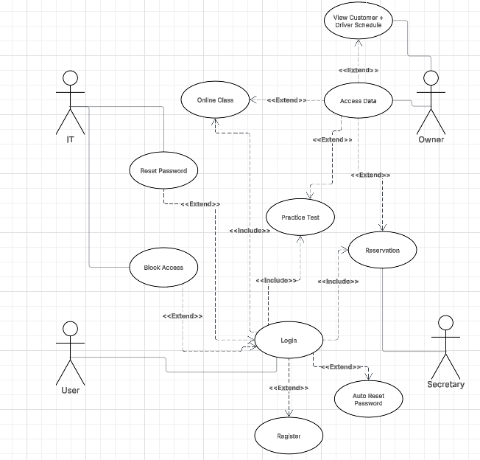

UML Activity Diagrams

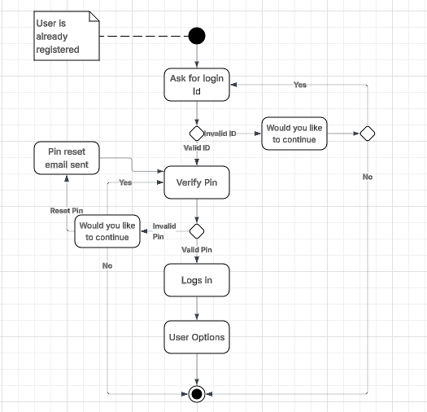
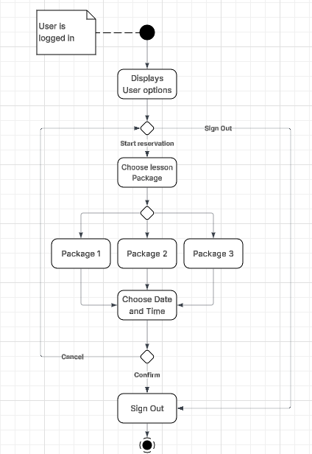

UML Sequence Diagram

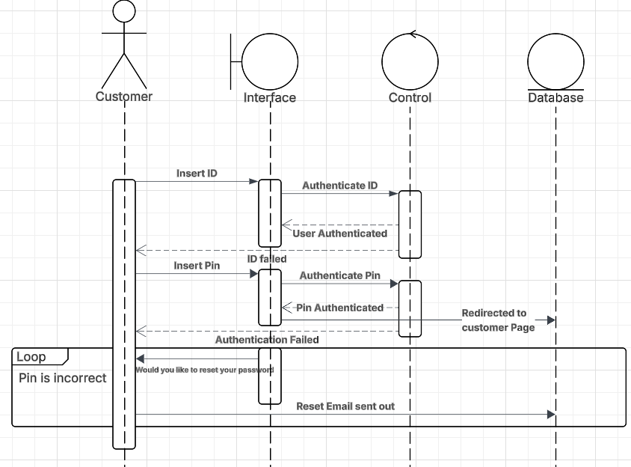

UML Class Diagram
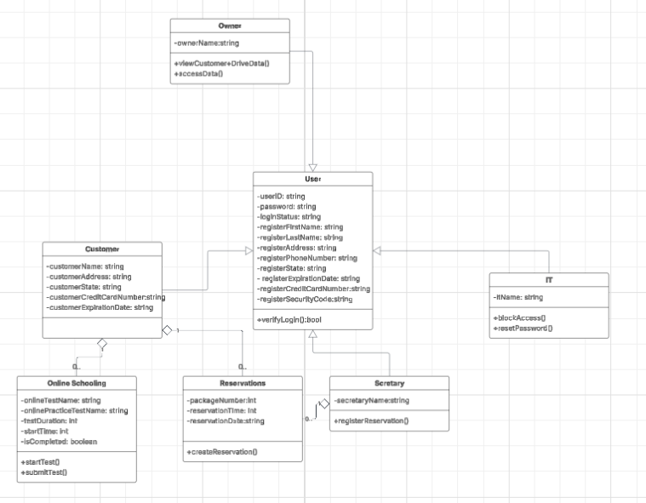

For the DriverPass system, the technical requirements of the system would include the need for a server to hold the system. The staff required to handle the Job of the IT, owner, and secretary. It would also require enough drivers to handle the on-site operations for those who make reservations with the system. The system will also require access to the cloud and internet.

